Type-C To 3-Port USB3 Hub And Integral
SDTMHC/TF/M2 Card Reader
Enable a powerful 3-Port USB Hub with the added convenience of a multi-functional Memory Card Reader
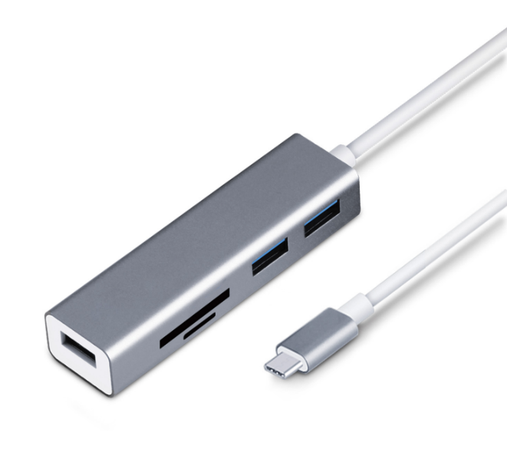

Descrption:
Combine the power of Type-C technology on your MacBookTM, WindowsTM or other digital device with an integral USB3 3-port Hub. Ideal for simultaneous connection of almost any USB device including keyboards, mice, USB storage at the same time.
With the added convenience of an integral, slot-style memory card reader for SDTMHC, TF and M2 style memory cards. Compact, stylish and totally self-powered with no additional drivers needed.

Features:
- Some USB Type-C laptops, tablets and computers have only one port for external connectivity, which limits the number of peripheral devices you can use. This USB-C Ethernet adapter features a built-in hub with three USB Type-C ports, giving you the freedom to attach additional devices, such as a USB mouse or flash drive. You can expand the number of USB ports you have to enhance your productivity.
- The USB-C multiport adapter features a memory card slot, providing fast read and write access for SD and microSD™ (with adapter) memory cards through USB 3.0. The card reader offers SD and micro SD support. It’s ideal for transferring photos or videos from your SD cards to your USB-C enabled laptop or tablet.
- Travel-sized and self-powered, this USB-C network adapter and hub provides easy portability, tucking easily into your laptop bag and eliminating the need to carry a separate Gigabit Ethernet adapter and USB-A hub. It’s ideal for mobile use, providing you with wired network connectivity wherever you go, and letting you plug in extra USB peripheral devices.
- Compatible with Windows 10/8/8.1/7 / Vista / XP and Mac OS X, Linux and Chrome OS
- Advantager: usb c hub, Multi port USB-C adapter, Advanced chipset , high quality, high speed, with great campatibility ,with great rejection of heat

Specifications
- Material: Alumiunm Alloy
- Color: dark grey
- Input: Type-C Male
- Interface: Usb 3.0*3/TF SD Card Reader
- speed :5Gbps
- Function: Charging+Data Transfer
- Certificate: CE FCC ROHS
- Operating Temperature:0℃ to +45℃
- Operating Humidity:10%0 to 85 % RH
- Storage Temperature : -10℃ to +55℃
- Storage Humidity: 5% to 90 % RH

Product Code:
Part number: C-TC-HUB4CR
Barcode: 8400800036605
Size: 12X10X3 cm
Weight:200G

